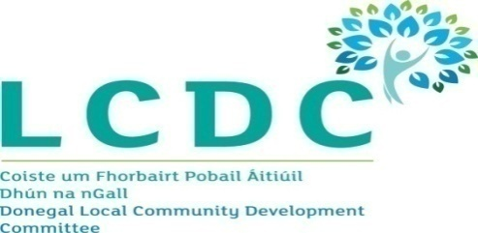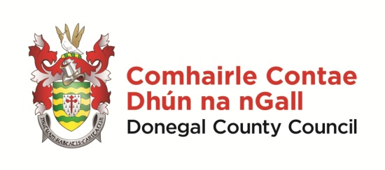

Minutes of Donegal Local Community Development Committee
Held in Council Chamber, County House, Lifford and by web conference 10.30 am on
15th November 2022

Members | Clr Maire Therese Gallagher, James O Donnell, Shauna McClenaghan, Charlene Logue, Aengus Kennedy and Andrew McNulty and remote attendance by Padraic Fingleton, Joe Boland, Anne McHugh, Maire Ui Mhaolain and Paul Hannigan
Apologies | Clr Niamh Kennedy (Chair), Clr Martin McDermott, John McLaughlin, Siobhan McLaughlin, Brenda Hegarty, Michael MacGiolla Easbuig and, Liam McElhinney
Chief Officer | Paddy Doherty
Attending | Liam Ward, Seamus Canning, Adrienne Kelly, Charlene Gillespie and Kathleen Browne

Welcome

In the absence of the Chairperson, Clr Niamh Kennedy and Vice Chairperson, Clr Martin McDermott, Clr Maire Therese Gallagher acted as Char of the meeting. She welcomed everyone and thanked the members present for participating in the meeting.

- Draft minutes of the LCDC meeting of 18th October 2022

The minutes of the previous LCDC Meeting, as circulated with the agenda, were considered. On the proposal of Shauna McCleanaghan, seconded by James O Donnell, the minutes of LCDC Meeting of 18th October 2022 were adopted with no issues arising.

- 2023-2027 LEADER Programme

Paddy Doherty advised members that the Minister for Rural and Community Development had announced the opening of the Leader Programme for the period 2023-2027. Member were advised that Co Donegal had received an allocation of €10.4 m out of a national allocation of €180 m.

Paddy informed members that DRCD were inviting Expressions of Interest from Local Action Groups for delivery of the LEADER Programme within each sub regional area (ie County or part there-of). He confirmed that EOI’s must be submitted to DRCD by 16th December. Following submission of the EOI, successful applicants will be invited to submit Local Development Strategies for their area.

Paddy detailed to members the broad range of local actors who were required to be included in the Local Action Group, including:-

- Representatives of local non-government organisations
- Local Development Companies
- Development Agencies
- Local Community based groups
- Marginalised Communities
- Youth Organisations
- Cultural Bodies
- Sporting Bodies
- Social Movements
- Networks
- Relevant Public Bodies

Paddy stated that he believed that the LCDC was very representative of the target groups mentioned. He advised that discussions had taken place with the current Implementing Partners regarding the LCDC being the LAG under the new Programme and it was understood that the four partners were agreeable to this proposal.

Members discussed the new LEADER programme. Aengus Kennedy queried whether the action plan for the new programme would be the same as the previous programme. Paddy Doherty confirmed that the Local Action Plan will determine this.

Padraic Fingleton noted the 19th reduction in the LEADER Allocation in the new programme and advised that the DLDC Board had met recently and sought clarity on how the funding allocated to the county would be split.

Liam Ward confirmed that the decision on allocations were based on a number of factors such as deprivation. He advised that details could be obtained and circulated to the LCDC should they wish to receive them.

Clr Maire Therese Gallagher reiterated the importance of LEADER funding to Comhar na nOilean and the islands and expressed the support of the LCDC for them to continue their good work. Maire UiMhaolain confirmed that Comhar na nOilean had met with the Minister and made a presentation to the Department in relation to delivery of the LEADER Programme through Comhair na nOilean. She advised that irrespective of the outcome they would continue to work closely with the LCDC and the LAG.

Liam Ward advised members that if the LCDC decides to submit an expression of interest to be the LAG for this iteration of LEADER there would be further engagement with Local Implementing Partners to develop a Local Development Strategy. Liam paid tribute to the work of the LCDC, the Implementing Partners and the LEADER Administrative Team in delivery of the current LEADER Programme. Clr Maire Therese Gallagher, on behalf of the LCDC, thanked the Implenting Partners and LEADER Administrative Team for their work in the delivery of the LEADER Programme to date.

On the proposal of Clr Maire Therese Gallagher, seconded by Charlene Logue, the LCDC recommended that they be the Local Action Group for County Donegal for the new LEADER Programme 2023-2027 and that an Expression of Interest be submitted in conjunction with the four Implementing Partners – Donegal Local Development CLG, Inishowen Development Partnership, Udaras na Gaeltachta and Comhair na nOilean.

- SICAP Case Studies Presentations

The SICAP Case Studies for 2022 had been submitted to Pobal and Department of Rural and Community Development in October. Representatives of the three Donegal Lots attended the meeting to make presentation to members of the 3 Case Studies submitted as follows:-

Lot 33-1 – Donegal Inishowen
Shauna McCleanaghan, IDP, made a presentation to members on the Lot 33-1 SICAP Case Study for 2022 which was under the Engagement Strategies with SICAP Target Groups/ Communities Theme and entitled Safe, Connected and Belonging – Inishowen’s Response to the Ukrainian Crisis”.

Lot 33-2 – Donegal Gaeltacht
Margaret Larkin and Joleen Kuyper, joined the meeting and introduced the video presentation of Lot 33-2 SICAP Case Study for 2022 which was under the Collaboration Theme and entitled “A SICAP response to Humanitarian Crisis: Supporting the Integration of Ukrainian Refuges”.

Lot 33-2 – Donegal
Louise Brogan, DLDC, also joined the meeting and introduced the video presentation of Lot 33-3 SICAP Case Study for 2022 which was under the Engagement Strategies with SICAP Target Groups (People with a disability) and entitled “Progression Pathways Project”.

On behalf of the LCDC, Clr Maire Therese Gallagher, thanked the representatives of the Local Development Companies for their excellent presentations and acknowledged their work on these projects.

Members discussed the issues raised in the presentations.

- Next Meeting

Members were informed that the next meeting of Donegal LCDC would be held on 14th December 2022 at 10.00 am.

This concluded the business of the meeting.

